**IT24103028**

**Probability and Statistics – IT2120**

**Lab - 10**

1. A vending machine owner claims that customers choose the four snack types (A, B,C, D) with equal probability. To test this claim, a researcher records the number

of purchases for each snack type during one week and results are given below.

i. State the null and alternative hypotheses for the test.

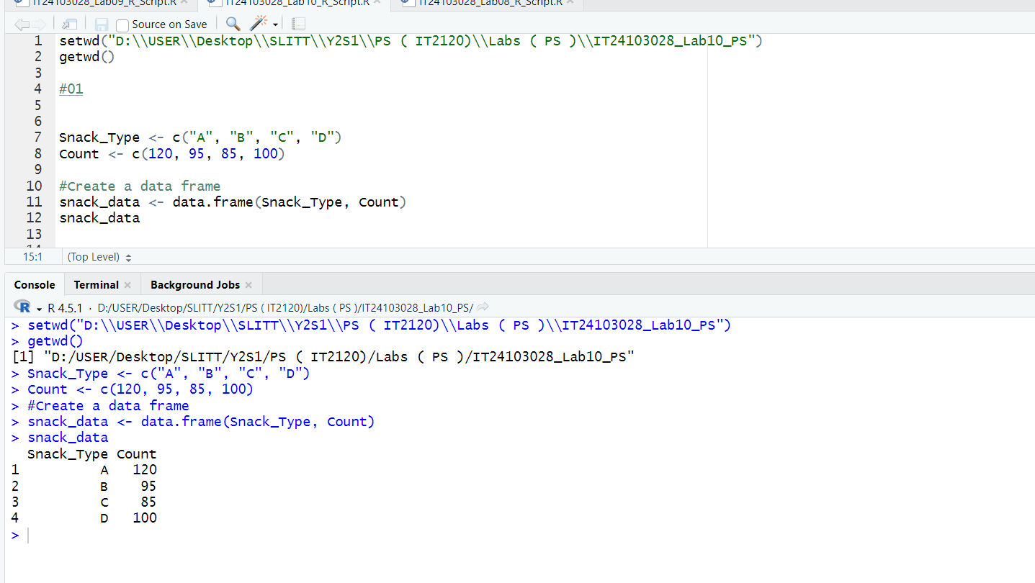

ii. Perform a suitable chi-squared test to test the null hypothesis..

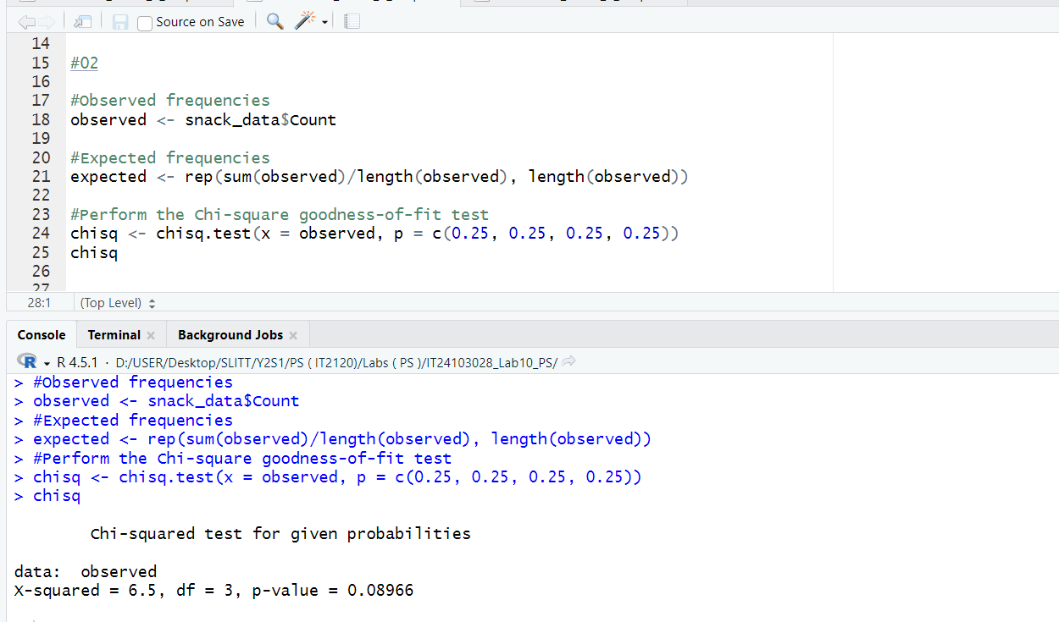

iii. Give your conclusions based on the results.

